ASSIGNMENT DOCUMENTATION MYSQL
ASSIGNMENT 2 – QUERYING DATA
BY MATHILAKATH SHARAN
Querying Data
Distinct Values
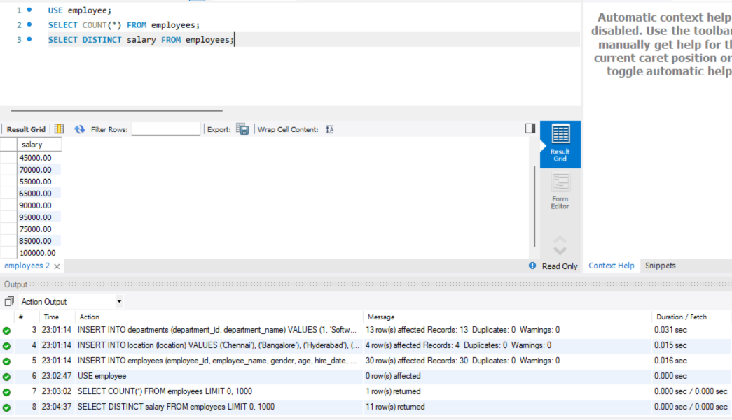
Alias (AS)
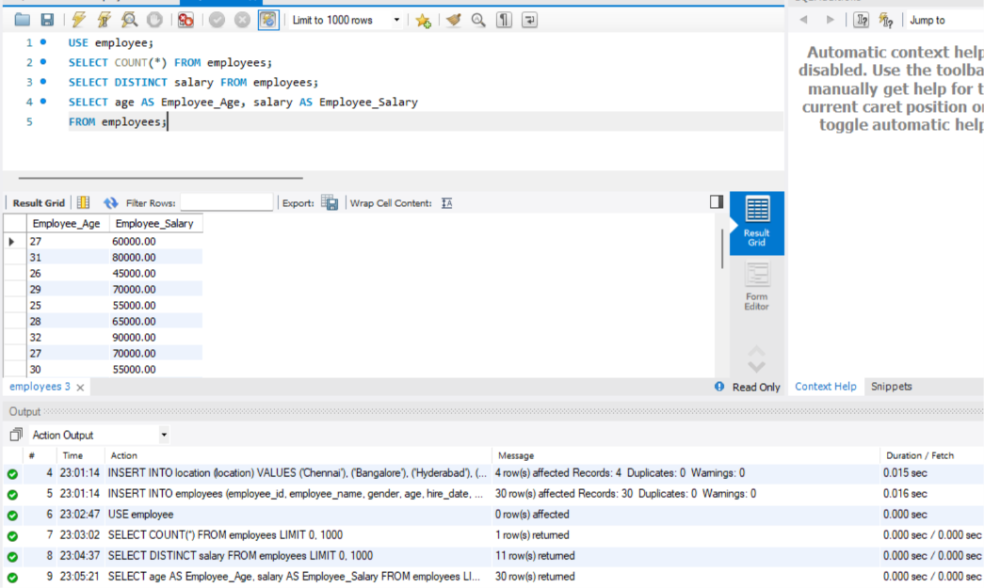
Where Clause and Operators: Salary above 50000 and hired before 2016-01-01
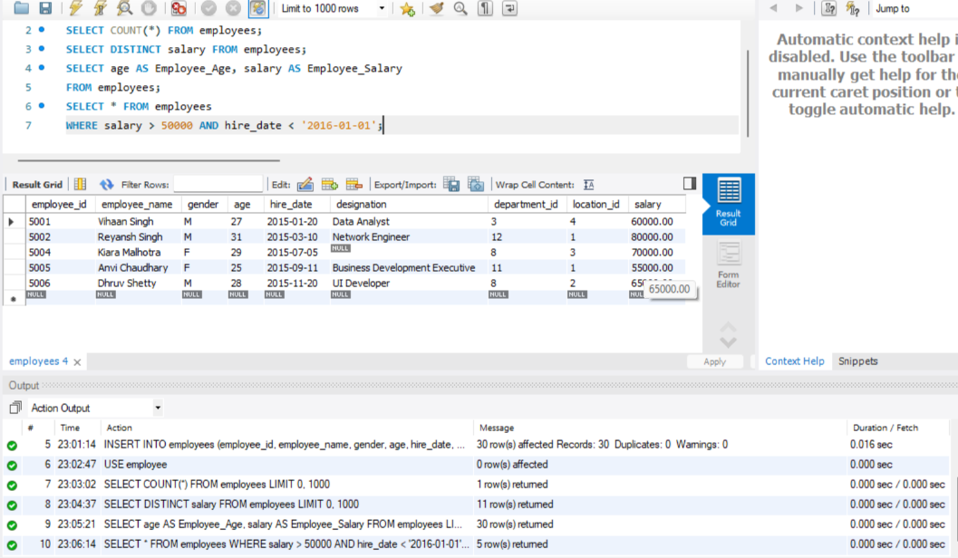
Where Clause and Operators: Employee with missing designation
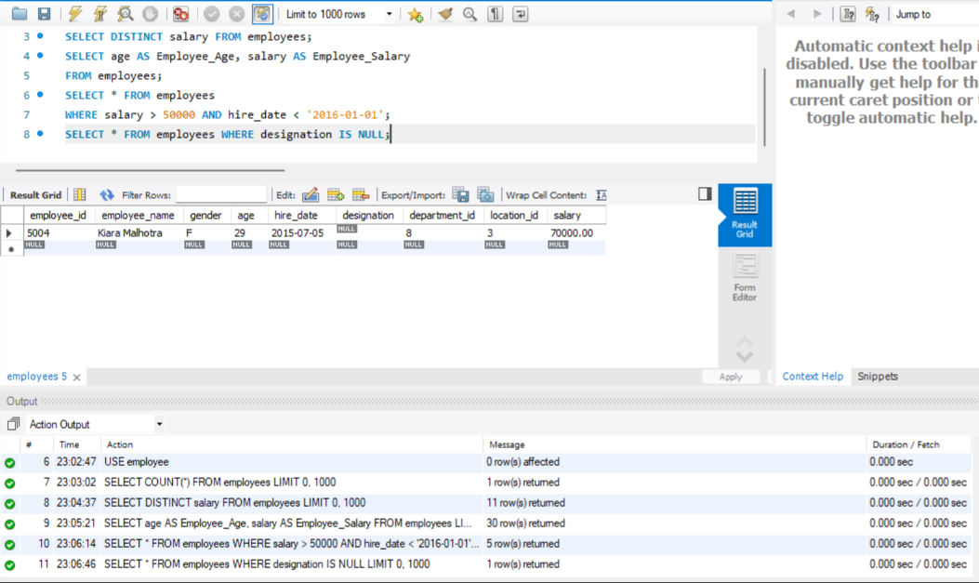
Updating the missing designation to Data Scientist
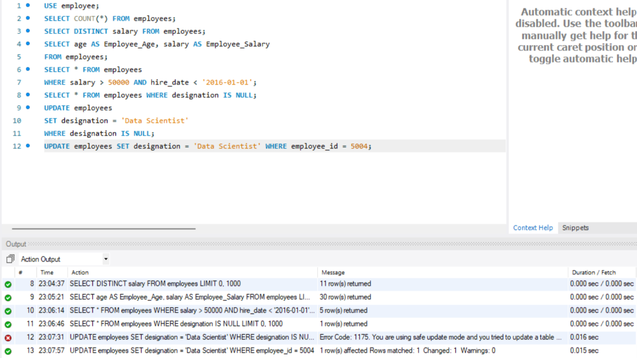
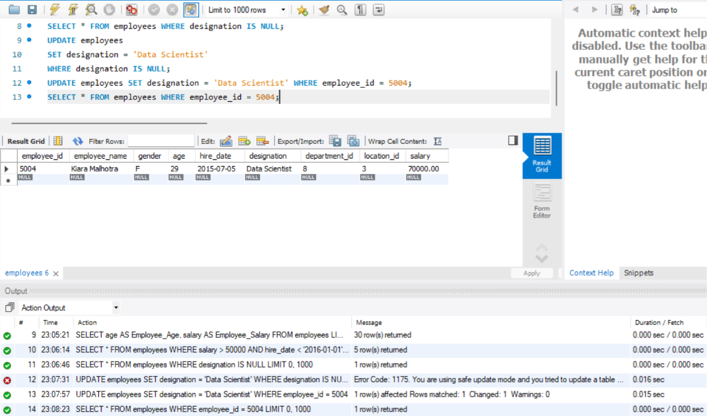
Sorting and Grouping Data
ORDER BY
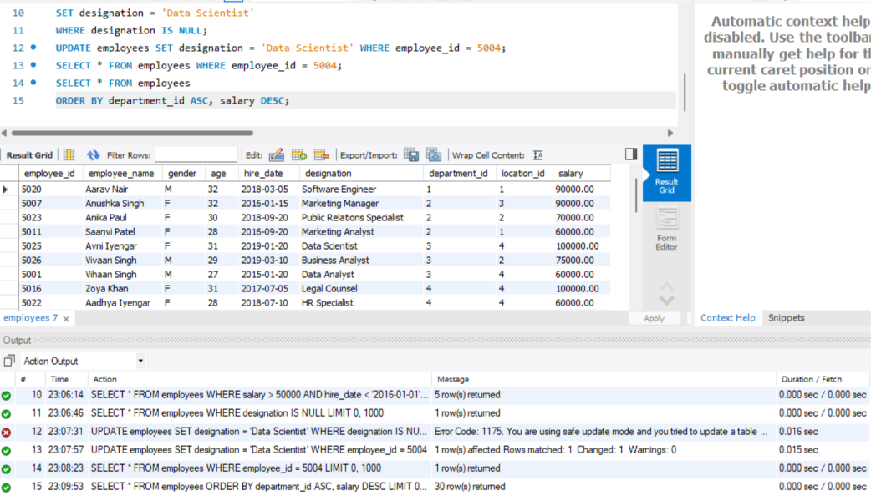
LIMIT
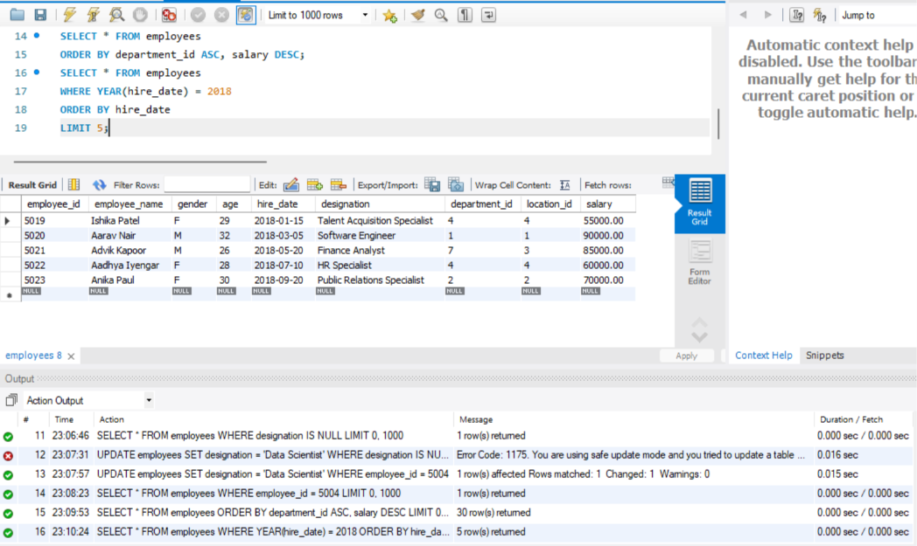
Aggregate Functions (SUM, MIN)
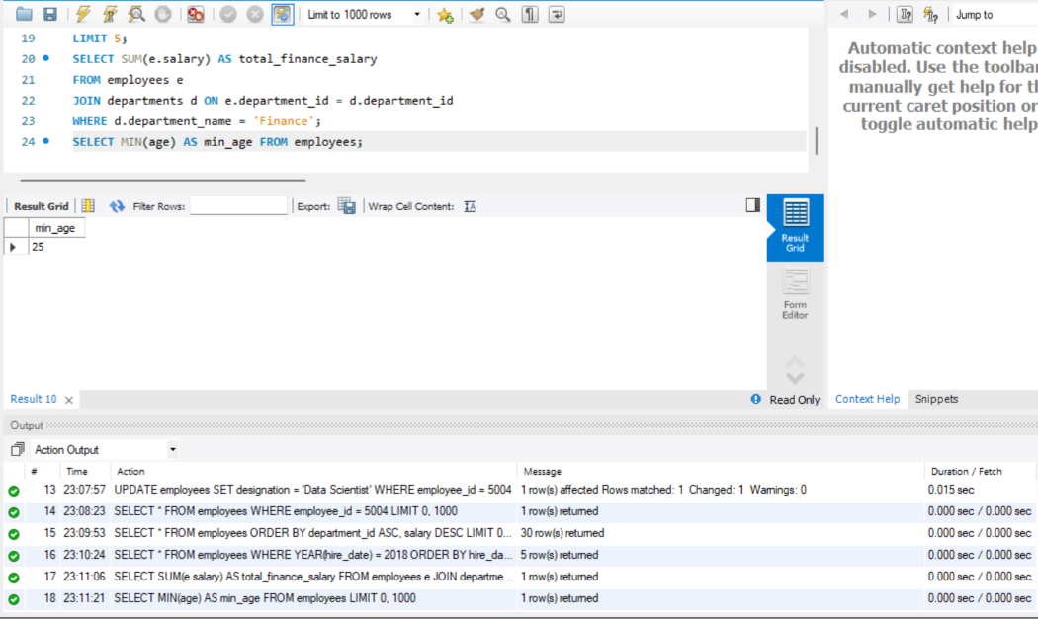
GROUP BY
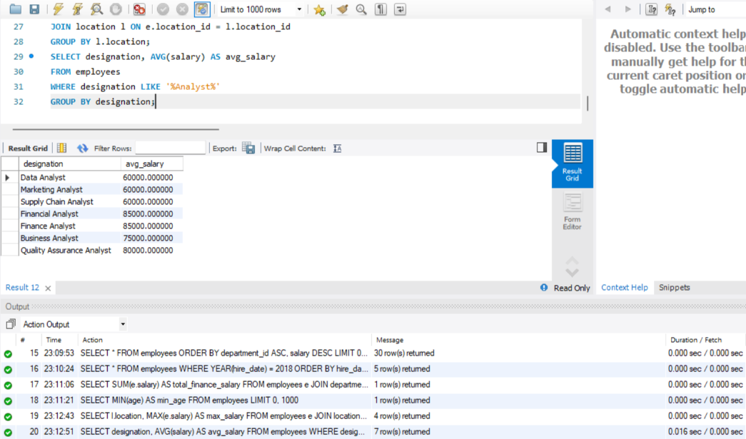
HAVING
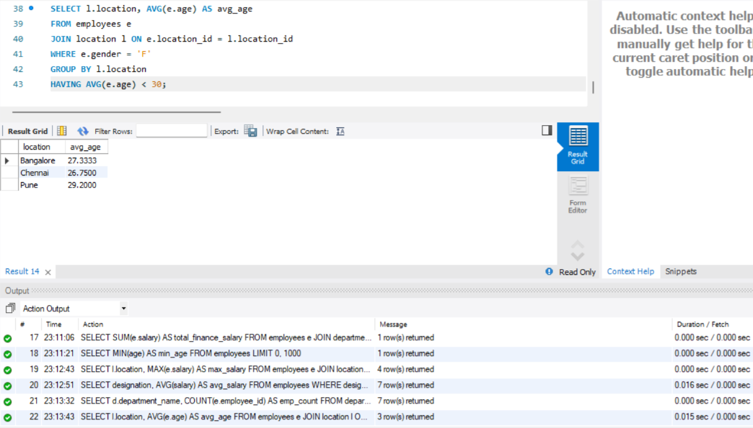
Joins
Inner Join, Left Join, Right Join


